**IE LT SPICE SIMULATION**

**GROUP 4**

AM RECEIVER

-Daksh Thapar 2018137

-Rahul Singh- 2018178

-Yashwin Agrawal- 2018205

**FULL CIRCUIT-**

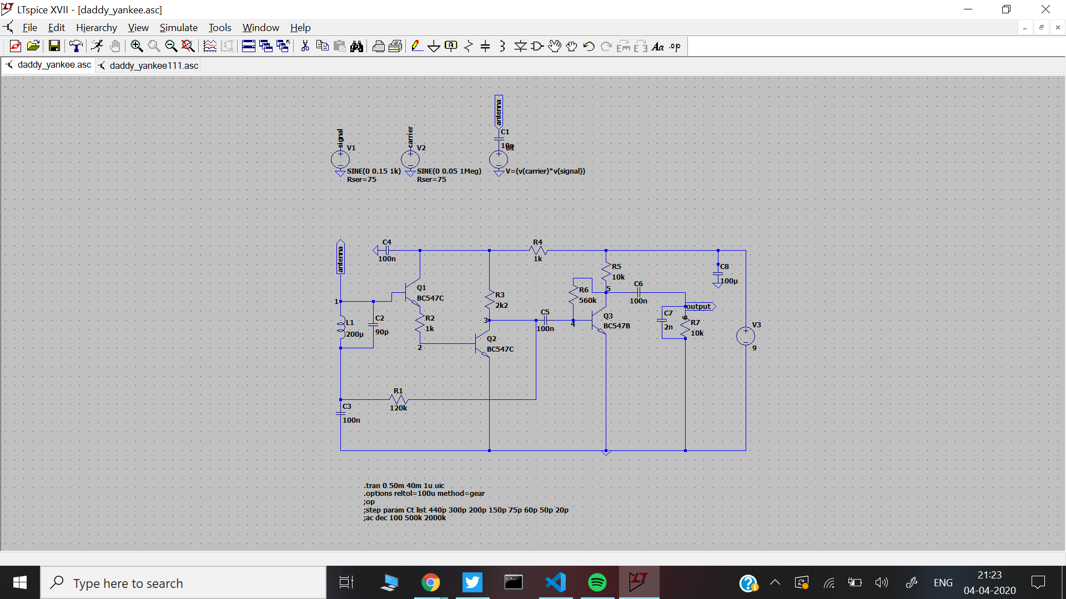

**STAGES IN AM RECEIVER-**

1. **Tuner Circuit-**

It is a subsystem that receives RF transmissions and converts the selected carrier frequency and its associated bandwidth into IF.

1. **RF Amplifier-**

Q2 and Q1 form a Darlington Pair for high gain and high impedance.

1. **Demodulator + Audio Amplifier-**

It is an electronic circuit used to recover the information content from the carrier wave signal.

Transistor Q3 has a dual purpose; it performs demodulation of the RF carrier whilst at te same time, amplifying the audio signal.

**Input Antenna Signal (***V1-> 1 in the circuit diagram)*

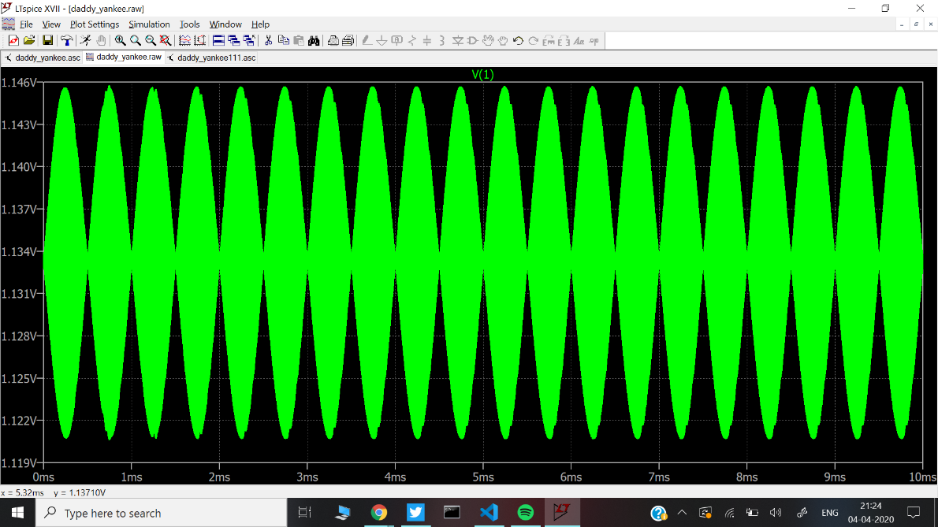

**RF Amplifier (***V3-> 3 in the circuit diagram)* 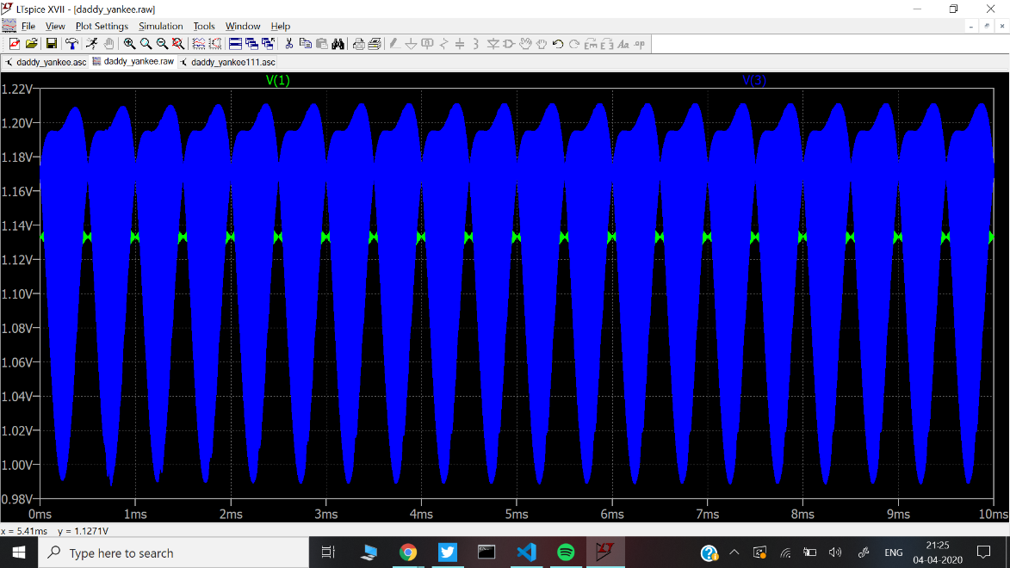

**Shift using Capacitor C5 (***V4-> 4 in the circuit diagram)*

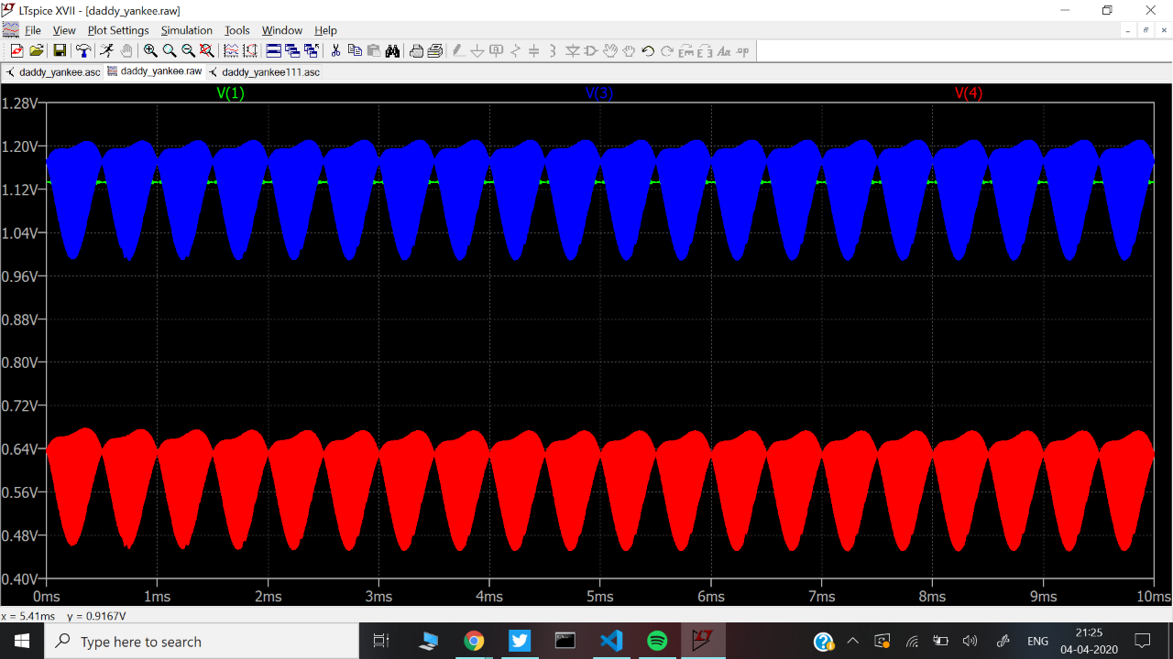

**Demodulator + Amplifier (***V6-> 6 in the circuit diagram)*

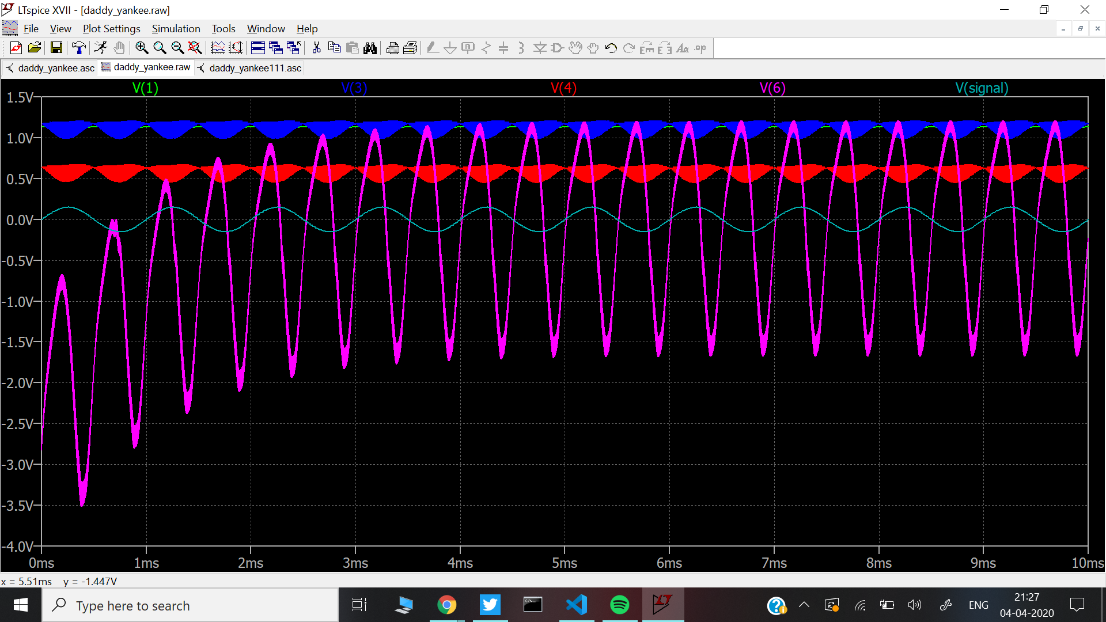

**INPUT MESSAGE SIGNAL VS RECEIVED SIGNAL**

(*V(signal)- Input signal, V(6)- received signal)*

